**Review Worksheet: Fossil Evidence for Evolution – dendrochronology, stratigraphy.**

Name: ……………………………………

*Do these questions, using your learning resources. Look at the “marks” to give you an idea of the level of detail required in the response (formative only – does not count towards your grade). At the end, mark your work, correct it, and fill in the reflection section. Questions marked * require you to use reasoning, inferring and application of knowledge, or perhaps extra research to get the answer. It won’t be right there in the text.*

1: What types of materials can be aged using radiocarbon dating?

(3 marks)

*……………………………………………………………………………………………………………………*

*……………………………………………………………………………………………………………………*

*……………………………………………………………………………………………………………………*

2: What types of materials can be aged using potassium-argon dating?

(2 marks)

*……………………………………………………………………………………………………………………*

*……………………………………………………………………………………………………………………*

3: What is dendrochronology? Is it a form of absolute dating, or relative dating?

(3 marks)

*……………………………………………………………………………………………………………………*

*……………………………………………………………………………………………………………………*

*……………………………………………………………………………………………………………………*

4: What is required to be able to date an ancient sample using dendrochronology?

(4 marks)

*……………………………………………………………………………………………………………………*

*……………………………………………………………………………………………………………………*

*……………………………………………………………………………………………………………………*

*……………………………………………………………………………………………………………………*

5: The following is a set of tree ring cores. A spare set of cores will be given to you on the last page in case you want to cut them out and sequence them. Look at the cores, and answer the following questions:

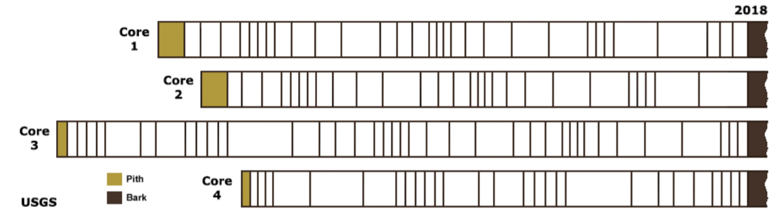

1. Which two trees started growing at the same time? (1 mark)

*……………………………………………………………………………………………………………………*

1. Which tree had lived the longest when its core was taken? (1 mark)

*……………………………………………………………………………………………………………………*

1. What is the earliest year represented in these tree cores? (1 mark)

*……………………………………………………………………………………………………………………*

1. Jim was born in 1972. Is it likely that the rainfall was good that year? Explain your answer. (3 marks)

*……………………………………………………………………………………………………………………*

*……………………………………………………………………………………………………………………*

*……………………………………………………………………………………………………………………*

6: What is the difference between absolute dating and relative dating?

(3 marks)

*……………………………………………………………………………………………………………………*

*……………………………………………………………………………………………………………………*

*……………………………………………………………………………………………………………………*

7: What is stratigraphy?

(3 marks)

*……………………………………………………………………………………………………………………*

*……………………………………………………………………………………………………………………*

*……………………………………………………………………………………………………………………*

8: Explain what is meant by the Principle of Superposition.

(2 marks)

*……………………………………………………………………………………………………………………*

*……………………………………………………………………………………………………………………*

9: What is correlation of rock layers and why is it useful?

(4 marks)

*……………………………………………………………………………………………………………………*

*……………………………………………………………………………………………………………………*

*……………………………………………………………………………………………………………………*

*……………………………………………………………………………………………………………………*

10: What are index fossils?

(3 marks)

*……………………………………………………………………………………………………………………*

*……………………………………………………………………………………………………………………*

*……………………………………………………………………………………………………………………*

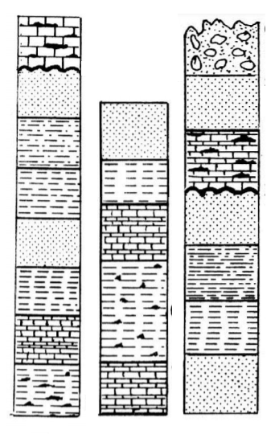

11: Shown here are three rock cores from different areas of

the world. A copy is on the last page so you can cut it

out to match it you wish.

1. Circle the oldest layer shown. (1 mark)
2. Place a cross through the youngest layer shown. (1 mark)

12: The diagram below shows rock strata at a variety of locations.

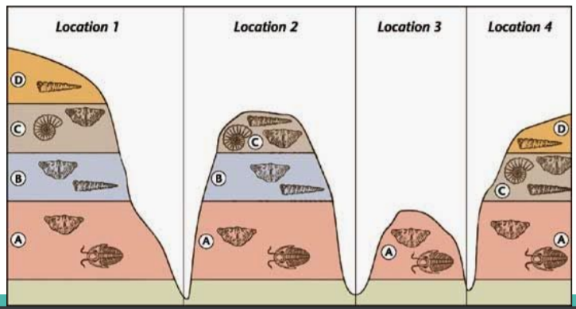

1. Circle one example of each fossil type that could best be used as index fossils.

(1 mark)*.*

1. Why is layer B not present in location 4?

(1 mark for either of the answers below)

*……………………………………………………………………………………………………………………*

*……………………………………………………………………………………………………………………*

1. Place a cross through one example of the most recently evolved organism. Explain why you made this choice.

(4 marks)

*……………………………………………………………………………………………………………………*

*……………………………………………………………………………………………………………………*

*……………………………………………………………………………………………………………………*

*……………………………………………………………………………………………………………………*

*……………………………………………………………………………………………………………………*

*……………………………………………………………………………………………………………………*

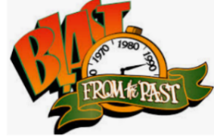13. Fill in the following table showing what is happening to membrane channels, ion movement and the membrane potential at each stage of an AP.

(14 marks)

|  |  |  |  |
| --- | --- | --- | --- |
|  | **Membrane channel activity** | **Ion movement** | **Membrane potential** |
| **Resting Membrane Potential (RMP)** |  |  |  |
| **Depolarisation** |  |  |  |
| **Repolarisation** |  |  |  |
| **Hyperpolarisation** |  |  |  |
| **Return to RMP** |  |  |  |

Go back and mark your work using the marking key provided. What score did you get? /55

*I included enough detail and scientific terminology in my answers.*



*I was able to find information in the text/powerpoint presentation.*

*I was able to reason and infer where the information wasn’t directly in the text (questions with *).*

*I marked my work and wrote down any answers where I missed marks.*

**Samples for cutting out and correlating if you wish….**



